**Name :** Poojitha Talari

**Trainer Name :** Harshee Pitroda

**Course :** Basics of Python and ML

**Date :** 30-05-2022

**Q1**

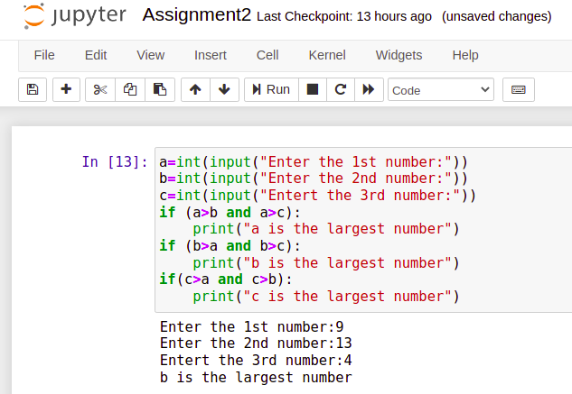

**Q2**

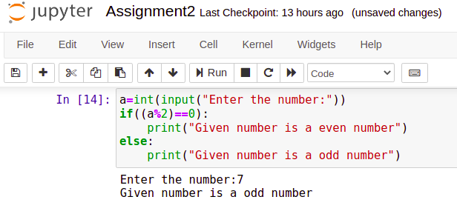

**Q3**

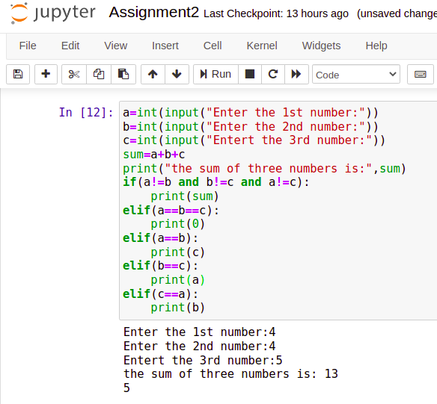

**Q4**

